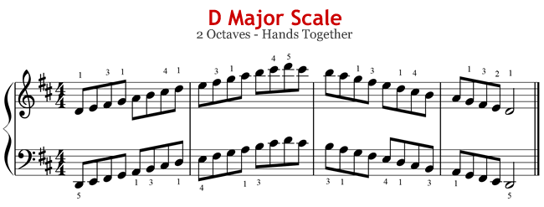

G MAJOR SCALE
2 Octaves Hands Together
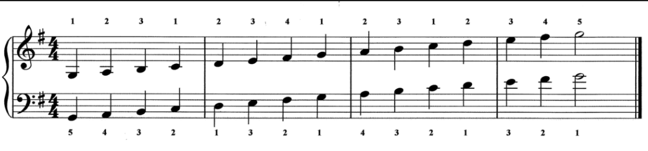

CHORD PROGRESSION: C Major (both hands)
